Ex.No.2
31/1/25 Implementing various visualization techniques using Time series data

AIM:
To implement the various visualization techniques using Time series data
Implementation:
import pandas as pd
import matplotlib.pyplot as plt
import seaborn as sns
df = pd.read_csv("ch1_discoveries.csv")
# Convert 'date' column to datetime format
df['date'] = pd.to_datetime(df['date'], format='%d-%m-%Y')
# Box Plot
plt.subplot(2, 3, 1)
sns.boxplot(y=df['Y'])
plt.title("Box Plot of Discoveries")
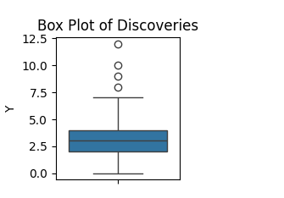
# Scatter Plot
plt.subplot(2, 3, 2)
plt.scatter(df['date'], df['Y'], color='red', alpha=0.6)
plt.title("Scatter Plot of Discoveries")
plt.xlabel("Year")
plt.ylabel("Discoveries")
plt.xticks(rotation=45)
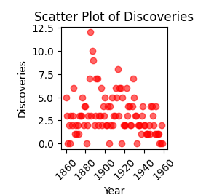
# Pie Chart (Grouped by occurrences of 'Y')
pie_data = df['Y'].value_counts()
plt.subplot(2, 3, 3)
plt.pie(pie_data, labels=pie_data.index, autopct='%1.1f%%', startangle=140)
plt.title("Pie Chart of Discovery Frequencies")

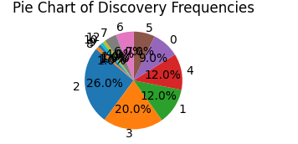
# Histogram
plt.subplot(2, 3, 5)
plt.hist(df['Y'], bins=10, color='green', alpha=0.7, edgecolor='black')
plt.title("Histogram of Discoveries")
plt.xlabel("Number of Discoveries")
plt.ylabel("Frequency")
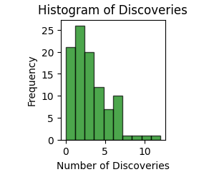
# Doughnut Plot
plt.subplot(3, 3, 7)
wedges, texts, autotexts = plt.pie(pie_data, labels=pie_data.index, autopct='%1.1f%%', startangle=140, wedgeprops={'width':0.4})
plt.setp(autotexts, size=8, weight="bold")
plt.title("Doughnut Chart of Discovery Frequencies")
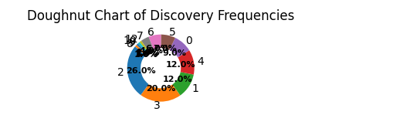

RESULT:
Thus the various visualization techniques were done successfully

